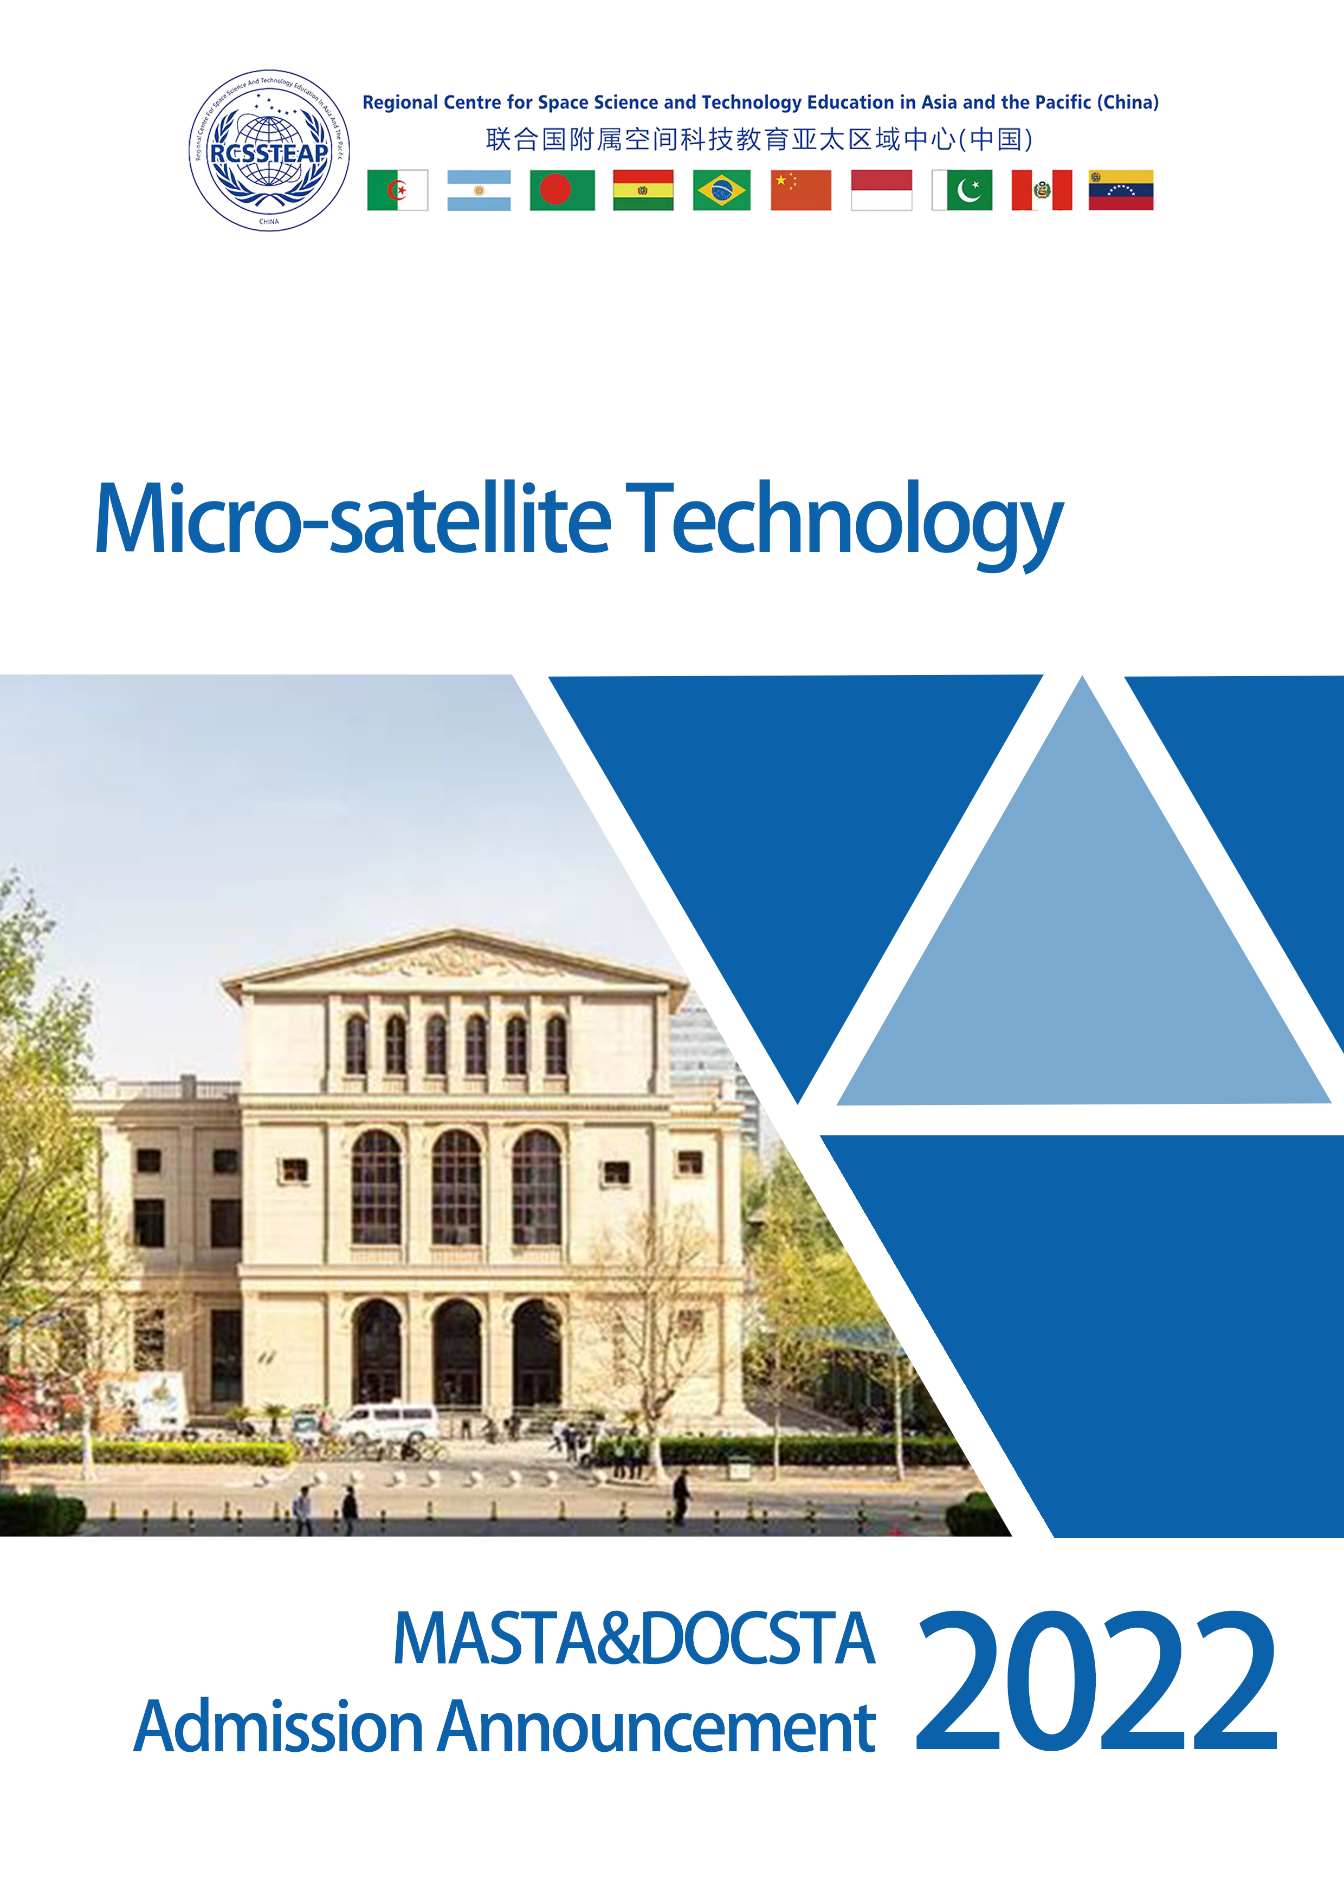

Overview
Space technology and its applications, the most fascinating technical achievement of humanity in the last six decades, have undoubtedly taken great strides forward. The various practical benefits of space technology play a central role in international development efforts.
In order to transform the recommendations of the United Nations Programme on Space Applications (UN-PSA) into practical and operable programme, Beihang University has initiated the Master Programme on Space Technology Applications (MASTA) since 2006. And in 2013, the Doctoral Programme on Space Technology Applications (DOCSTA) was launched.
MASTA is an elaborately designed and intensive Master programme for students who are interested in exploring the mysterious universe. This application-oriented programme focuses on both knowledge acquisition and operational training. While DOCSTA focuses on training participants with solid theoretical knowledge and systematic expertise in the field of space technology applications. MASTA&DOCSTA aims to deliver “International, Interdisciplinary, Intercultural, Innovative, Identical (5I)” education and provide a powerful platform for scholars and professionals to obtain more opportunities for communicating and experiencing the space technology practice in China.
MASTA is designed to give participants a competitive advantage by:
- Broadening their knowledge on space-related issues and activities and encouraging participants to use acquired knowledge and skills through practical, hands-on experience;
- Providing a variety of practice opportunities (including watching satellite launches on site, attending international conferences/workshops, etc.);
- Internationally qualified professors and experts from a diversity of academic backgrounds;
- Modularized curricula design and flexible study modes;
- Developing cross-cultural communication skills in an internationalized atmosphere.
The main educational fields of MASTA Programme include Remote Sensing and Geographic Information System (RS&GIS), Satellite Communications, Global Navigation Satellite Systems (GNSS), Micro-satellite Technology, Space Law and Policy, Space Science and Environment, etc.
Doctoral Participants are expected to have the ability to conduct the independent scientific research, explore applications or engage in professional careers in related fields.
Candidates are expected to have a profound grasp and understanding of new technology and development in space science technology and applications. They are required to finish the dissertation with high practicability and application prospects.
Lectures are conducted in English. The thesis for project practice is required to be written in English.
Participants will be awarded with the Graduation Certificate of Beihang University and Master’s/Doctoral Degree Certificate of the People’s Republic of China when fulfilling the required credits and passing the thesis defense.
The faculty of both programmes consists of professors, experts and senior engineers from Beihang University and some other institutes or academies of China and abroad. The core faculty members have long and varied experience in the field of space science and technology. In addition, they have accumulated considerable teaching experience over the years and are skilled in teaching and advising international students.
For more details, please visit our website: http://rcssteap.buaa.edu.cn/kjkjjyev/Education.htm

Beihang University
Beihang University (previously known as Beijing University of Aeronautics and Astronautics) was founded on October 25, 1952 under the name of Beijing Institute of Aeronautics, originating from the merger of the aeronautical departments of Tsinghua University, Beiyang University, Xiamen University, Sichuan University, etc. Located in the center of the Zhongguancun Science Park and within easy reach of central Beijing, Beihang is the first university in China focusing on aeronautical and astronautical education and research. About 26km away from the main campus, the suburban Shahe campus provides quiet study milieu and is also home to the National Laboratory of Aeronautics and Astronautics (NLAA). The very new Doudian campus aims at research and innovation through engineering combined with medicine.
For more details, please visit: https://ev.buaa.edu.cn

Training Mode
The credit system is applied to postgraduates studying in China, which includes course study, practice and degree thesis. The supervisor shall bear the responsibility of cultivating international postgraduates. The supervisor (group) should be responsible for making the training plan of international students, guiding their thesis proposals, scientific research and thesis writing.
No changing in major or supervisor is permitted after three months since the registration unless there is a special reason.
For more details, please visit our websites:
MASTA- http://rcssteap.buaa.edu.cn/kjkjjyev/Education/MASTA_Program.htm
DOCSTA- http://rcssteap.buaa.edu.cn/kjkjjyev/Education/DOCSTA_Program.htm

Qualifications
- Comply with the laws and regulations of the People's Republic of China and Beihang University rules;
- Applicants must be non-Chinese citizens with a valid passport in compliance with the provisions of Nationality Law of the People's Republic of China, under the age of 35 for MASTA, under the age of 40 for DOCSTA;
- Applicants should have some professional experience working in space technology industry or research institutes;
- Applicants for MASTA should have Bachelor’s Degree; Applicants for DOCSTA should have Master’s Degree;
- Applicants are expected to have good command of English and the ability to take courses in English;
- Applicants are supposed to have research background in relevant areas.
Please notice: We warmly welcome the applicants with Bachelors’ Degree or Masters’ Degree obtained from the QS World University Rankings Top 500, or from ARWU Top 500 universities.
Applicants of both programmes are mostly recommended by organizations. Students who are interested to do self-sponsor, please visit website (http://admission.buaa.edu.cn) for further information.

Fees
- Application Fee: 400 Yuan (RMB)
- Tuition Fees: 35000 Yuan (RMB) / year for MASTA, 42000 Yuan (RMB) / year for DOCSTA
- Insurance: 800 Yuan (RMB) / year
- Accommodation: Double-bed room, 750 Yuan (RMB)/month; per bed (not including costs like water, electricity, etc.)
Note: Both programmes are mainly for directional enrollment. Students who are interested to do self-sponsor, please visit website (http://admission.buaa.edu.cn) for further information.

Scholarship

1. Applicants are welcomed to apply for the Chinese Government Scholarship (CSC Scholarship) at Beihang University.

The Full Scholarship of CSC will cover the following items:
- Tuition fees
- Accommodation
- Living allowance
- Comprehensive insurance
The scholarship does not contain:
- International travel expenses

2. Applicants who fail to get the CSC Scholarship will have chance to get Beijing Municipal/Beihang Scholarship. Beijing Municipal/Beihang Scholarship will only cover tuition fee.

Required Documents
- Application Form for Chinese Government Scholarship.
- Highest Education Diploma (notarized photocopy) or Certificate of Expected Graduation from the university studying currently. Information such as date of official graduation certificate obtained should be included.
- Notarized Transcripts.
- Study or Research Plan (no less than 500 words).
- Two Recommendation Letters from Professors or Academic Experts.
- The results of TOEFL (90 or above), IELTS (6 or above), Duolingo (110 or above) or the English teaching Certificate issued by the university is required (Except for applicants whose native language is English).
- Photocopy of Physical Examination Form and Blood Examination Report.
Attachment 1-FOREIGNER PHYSICAL EXAMINATION FORM.pdf
- If you use bank remittance service to pay the application fee, please submit the copy of Remittance Receipt for Application Fee (RMB 400 or USD 70). Please write down the applicant’s name and passport information on the receipt. If you choose the PAYEASE service via the application system, no need to submit the receipt. Photocopy of Remittance Receipt for Application Fee (RMB 400 or USD 70).
- Photocopy of First Page of Passport (the information page).
- Resume (if the study or work experience is not continuous, please attach an explanation).
- An Integrity Commitment letter to ensure the authenticity of all the application materials you provide.
Attachment 2- the Integrity Commitment Letter template
- Non-Criminal Record Report. If you currently study in China, please consult the local police system to provide. If you are unable to provide this document, as a substitute, please explain the situation and provide a non-criminal record commitment in handwriting.
Attachment 3- non-criminal record commitment template
- The List of Application Documents and Post Address confirmed.
Attachment 4- List of Application Documents.doc

Note: - Documents should be in English or Chinese or attached with translations in English or Chinese.

- Your document review process will only start after your application fee receipt submitted in the system or you have successfully paid in the application system directly.

- If there is any authenticity issue about your application materials, your application will be disqualified immediately.

- The Non-Criminal Record Report is a required document in the CSC system. Applicants who fail to upload this document will not be able to complete the application online.

How to apply
- Applicants shall follow the instructions below to execute your application process, please be careful to select the correct Program Category “TYPE B” and accurate Agency Number for Beihang University “10006”.
- Please note that the specialty should be chosen as “Space Technology Applications” and the instruction language should be chosen as “English”.
- All applicants shall submit your application in both Beihang University International Students Online Application System and CSC official system. Links are as below:
Beihang International Student Online Application System: http://admission.buaa.edu.cn
CSC system: http://studyinchina.csc.edu.cn
- Beihang will organize document review, preliminary interview, and academic interview in different batches. Interview will be conducted online through ZOOM or Tencent meeting platform. The best candidates will be selected according to the comprehensive evaluation processes and results. Admission results will be announced after mid-June 2022.
- Admission notices and relevant documents will be sent to applicants by e-mail or express delivery around August 2022.

Please notice:

- You must complete your application in BOTH Beihang and CSC systems. Please ensure that the documents uploaded in the two systems are consistent. Otherwise, your application will be treated as invalid and incomplete.

- Beihang university never authorize any intermediary agency to carry out scholarship enrollment. Please do not trust paid services and false promises from intermediaries.

- The major COULD NOT be changed once your admission is confirmed.

- Please make sure all the documents are saved as PDF file. If the format does not meet the requirement, the documents will not be reviewed.

- Hard copies of the documents are not required for application in 2022.

How to pay the application fee
There are two options for your payment.
1. You pay the application fee through the PAYEASE online payment function in the application system.
2. You pay the application fee by bank remittance service.

Beneficiary info for Application Fee

For USD
Beneficiary Name: BEIHANG UNIVERSITY
Account No.: 0200006209026400229
Beneficiary Banker's Name: Industrial and Commercial Bank of China, Beijing Dongsheng Road Branch, Beijing, China
Swift Code: ICBKCNBJBJM

For RMB
账户名：北京航空航天大学
账号：0200006209026400229
收款行：中国工商银行北京分行东升路支行

Please notice
- Application Fee paid via WeChat / Alipay / PayPal or cash will not be accepted.
- If you pay by bank remittance, please write down applicant’s name and passport information on the receipt before submitting the application system.
- Please double check for yourself whether you need to pay the application fee or not in advance. Payment is non-refundable.

Important Dates
- Applicants should mail the required application documents to the Contact Person at APSCO by March 15, 2022.
- Applications received later than March 15, 2022 will not be accepted.
- The programme will start in early September 2022.

Contact Information
- Ms. Charis Xiong,
Address: ASIA-PACIFIC SPACE COOPERATION ORGANIZATION (APSCO)
Building 13&14, Section 3, No.188, South Street Fourth Ring, Fengtai District,
Beijing, China
- Telephone: +86-10-63702677-404
- E-mail: charis@apsco.int
- Website of APSCO: http://www.apsco.int
- Website of International School, Beihang University: http//is.buaa.edu.cn
- Website of Beihang University: http://ev.buaa.edu.cn
- Website of China Scholarship Council: http://studyinchina.csc.edu.cn
- You may find more details and FAQ via http://is.buaa.edu.cn/en/info/1416/2324.htm
In 2022, MASTA Programme provides three educational fields: Satellite Communications and Global Navigation Satellite Systems (SC&GNSS), Remote Sensing and Geo-information System (RS&GIS), Micro-satellite Technology. The followings are detailed information of Micro-satellite Technology.

Micro-satellite Technology
During the past decades, micro-satellites have been widely applied to conduct space experiments, demonstrate new technologies and perform operational missions. Micro-satellite has become one of the key fields for future space exploration. Because of its functional simplicity, small size, light weight, short design cycle, and low cost, micro-satellite technology is extremely suitable for development in universities. On the other hand, although small or micro-satellites seem to be samples in terms of functionality and systems, such satellites still consist of subsystems that almost cover all the technologies of normal satellite design and manufacturing, making it an efficient way for students to study and develop space technology through special micro-satellite projects. Many universities in the world are now endeavoring in various micro-satellites, Surrey University in British and Delft University of Technology are examples.
To enhance students’ innovation and engineering abilities in spacecraft design, a student micro-Satellite (BUAA-SAT) programme is sponsored by Beihang University. The Micro-satellite Technology programme of the Centre, an offshoot of BUAA-SAT, is an English-taught programme for international students. After years of work, BUAA-SAT has completed its preliminary design phase. All subsystems have been prototyped and demonstrated. Qualified tests for flight models and space environments have also been conducted.
Based on the design of BUAA-SAT, APSCO SSS-1 satellite has been developed by both foreign and Chinese students since 2016. At 18:51 on October 14, 2021, APSCO SSS-1 was successfully launched by piggy-backing the CZ-2D rocket from Taiyuan Satellite Launch Center in Shanxi, China. SSS-1 is working well in in-orbit tests, and the telemetry signal shows that SSS-1 is in good condition. Meanwhile, a training platform for micro-satellite has been formed at Beihang University, which contains document materials for design, simulation as well as devices and facilities for test. Beihang University has developed micro-satellite laboratory with professional facilities, such as TT&C (Telemetry, Telecommand and Communication) ground station, clean room and vacuum tank for space environment tests. Students could participate in the design and experiments of the micro-satellite subsystems. Beihang University also developed close cooperation with China’s aerospace industry. Technical visits and professional lectures are organized regularly.

9-month Course List
No. |  | Item |  | Class Hrs | Credits | Remark
Module Ⅰ Platform Courses
PC1-1 | Probability and Statistics in Engineering |  | 48 |  | 3 | Select at least 3 credits of them
PC1-2 | Theory of Matrix |  | 48 |  | 3
PC1-3 | Numerical Analysis |  | 48 |  | 3
PC2-1 | Matlab Programming |  | 32 |  | 2 | Compulsory/ Optional
PC3-1 | Space Environment, Orbit and Spacecraft Systems |  | 48 |  | 3 | Compulsory
PC3-2 | Introduction to Space Technology Applications |  | 18 |  | 1 | Compulsory
PC3-3 | International Cooperation in the Peaceful Uses of Outer Space |  | 16 |  | 1 | Compulsory/ Optional
PC4-1 | Chinese (level 1) |  | 60 |  | 2 | Compulsory
PC4-2 | Chinese (level 2) |  | 60 |  | 1 | Compulsory
PC4-3 | Introduction to China |  | 16 |  | 1 | Compulsory
PC5-1 | Scientific Literature Retrieval |  | 16 |  | 1 | Compulsory/ Optional
Module Ⅱ Major Basic Courses & Major Courses
MC4-1 | Orbital Mechanics |  | 48 |  | 3 | Compulsory
MC4-2 | Spacecraft Structure and Mechanism Design |  | 32 |  | 2 | Compulsory
MC4-3 | Practice of MSC.Patran / Nastran |  | 16 |  | 1 | Compulsory
MC4-4 | Satellite OBDH System Design and Test |  | 32 |  | 2 | Compulsory
MC4-5 | Thermal Control Technology of Spacecraft |  | 32 |  | 2 | Compulsory
MC4-6 | Small Satellite’s System Design and Engineering Practice |  | 40 |  | 2 | Compulsory
MC4-7 | Attitude Control System Design of Satellite |  | 16 |  | 1 | Compulsory
MC4-8 | Experiments of Microsatellite System |  | 16 |  | 1 | Compulsory
Module Ⅲ Team Pilot Projects
PPC | Team Pilot Project |  | 12 Weeks |  | 6 | Compulsory

Professionals/Experts
Please visit: http://rcssteap.buaa.edu.cn/kjkjjyev/Education/Faculty___Staff/Faculty.htm

Partners
Please visit: http://rcssteap.buaa.edu.cn/kjkjjyev/Cooperation/Partners.htm

Facilities
Please visit: http://rcssteap.buaa.edu.cn/kjkjjyev/Life_at_RCSSTEAP/Facilities.htm

