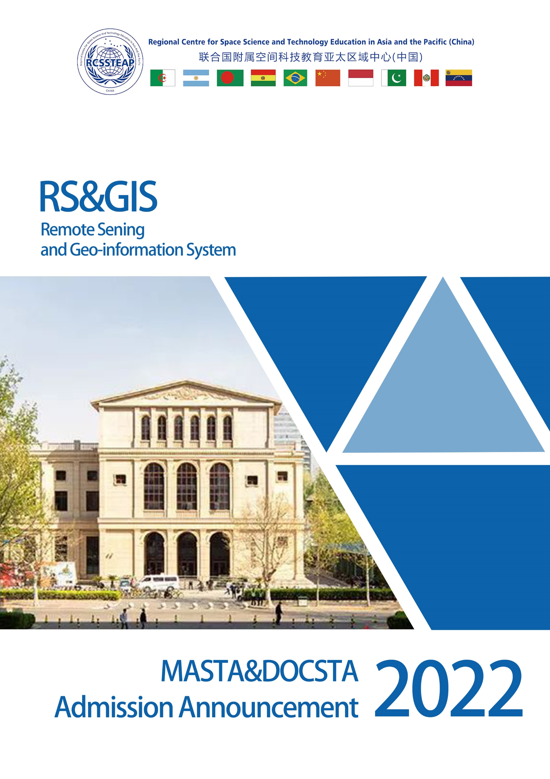

Overview
Space technology and its applications, the most fascinating technical achievement of humanity in the last six decades, have undoubtedly taken great strides forward. The various practical benefits of space technology play a central role in international development efforts.
In order to transform the recommendations of the United Nations Programme on Space Applications (UN-PSA) into practical and operable programme, Beihang University has initiated the Master Programme on Space Technology Applications (MASTA) since 2006. And in 2013, the Doctoral Programme on Space Technology Applications (DOCSTA) was launched.
MASTA is an elaborately designed and intensive Master programme for students who are interested in exploring the mysterious universe. This application-oriented programme focuses on both knowledge acquisition and operational training. While DOCSTA focuses on training participants with solid theoretical knowledge and systematic expertise in the field of space technology applications. MASTA&DOCSTA aims to deliver “International, Interdisciplinary, Intercultural, Innovative, Identical (5I)” education and provide a powerful platform for scholars and professionals to obtain more opportunities for communicating and experiencing the space technology practice in China.
MASTA is designed to give participants a competitive advantage by:
- Broadening their knowledge on space-related issues and activities and encouraging participants to use acquired knowledge and skills through practical, hands-on experience;
- Providing a variety of practice opportunities (including watching satellite launches on site, attending international conferences/workshops, etc.);
- Internationally qualified professors and experts from a diversity of academic backgrounds;
- Modularized curricula design and flexible study modes;
- Developing cross-cultural communication skills in an internationalized atmosphere.
The main educational fields of MASTA Programme include Remote Sensing and Geographic Information System (RS&GIS), Satellite Communications, Global Navigation Satellite Systems (GNSS), Micro-satellite Technology, Space Law and Policy, Space Science and Environment, etc.
Doctoral Participants are expected to have the ability to conduct the independent scientific research, explore applications or engage in professional careers in related fields.
Candidates are expected to have a profound grasp and understanding of new technology and development in space science technology and applications. They are required to finish the dissertation with high practicability and application prospects.
Lectures are conducted in English. The thesis for project practice is required to be written in English.
Participants will be awarded with the Graduation Certificate of Beihang University and Master’s/Doctoral Degree Certificate of the People’s Republic of China when fulfilling the required credits and passing the thesis defense.
The faculty of both programmes consists of professors, experts and senior engineers from Beihang University and some other institutes or academies of China and abroad. The core faculty members have long and varied experience in the field of space science and technology. In addition, they have accumulated considerable teaching experience over the years and are skilled in teaching and advising international students.
For more details, please visit our website: http://rcssteap.buaa.edu.cn/kjkjjyev/Education.htm

Beihang University
Beihang University (previously known as Beijing University of Aeronautics and Astronautics) was founded on October 25, 1952 under the name of Beijing Institute of Aeronautics, originating from the merger of the aeronautical departments of Tsinghua University, Beiyang University, Xiamen University, Sichuan University, etc. Located in the center of the Zhongguancun Science Park and within easy reach of central Beijing, Beihang is the first university in China focusing on aeronautical and astronautical education and research. About 26km away from the main campus, the suburban Shahe campus provides quiet study milieu and is also home to the National Laboratory of Aeronautics and Astronautics (NLAA). The very new Doudian campus aims at research and innovation through engineering combined with medicine.
For more details, please visit: https://ev.buaa.edu.cn

Training Mode
The credit system is applied to postgraduates studying in China, which includes course study, practice and degree thesis. The supervisor shall bear the responsibility of cultivating international postgraduates. The supervisor (group) should be responsible for making the training plan of international students, guiding their thesis proposals, scientific research and thesis writing.
No changing in major or supervisor is permitted after three months since the registration unless there is a special reason.
For more details, please visit our websites:
MASTA- http://rcssteap.buaa.edu.cn/kjkjjyev/Education/MASTA_Program.htm
DOCSTA- http://rcssteap.buaa.edu.cn/kjkjjyev/Education/DOCSTA_Program.htm

Qualifications
- Comply with the laws and regulations of the People's Republic of China and Beihang University rules;
- Applicants must be non-Chinese citizens with a valid passport in compliance with the provisions of Nationality Law of the People's Republic of China, under the age of 35 for MASTA, under the age of 40 for DOCSTA;
- Applicants should have some professional experience working in space technology industry or research institutes;
- Applicants for MASTA should have Bachelor’s Degree; Applicants for DOCSTA should have Master’s Degree;
- Applicants are expected to have good command of English and the ability to take courses in English;
- Applicants are supposed to have research background in relevant areas.
Please notice: We warmly welcome the applicants with Bachelors’ Degree or Masters’ Degree obtained from the QS World University Rankings Top 500, or from ARWU Top 500 universities.
Applicants of both programmes are mostly recommended by organizations. Students who are interested to do self-sponsor, please visit website (http://admission.buaa.edu.cn) for further information.

Fees
- Application Fee: 400 Yuan (RMB)
- Tuition Fees: 35000 Yuan (RMB) / year for MASTA, 42000 Yuan (RMB) / year for DOCSTA
- Insurance: 800 Yuan (RMB) / year
- Accommodation: Double-bed room, 750 Yuan (RMB)/month; per bed (not including costs like water, electricity, etc.)
Note: Both programmes are mainly for directional enrollment. Students who are interested to do self-sponsor, please visit website (http://admission.buaa.edu.cn) for further information.

Scholarship

1. Applicants are welcomed to apply for the Chinese Government Scholarship (CSC Scholarship) at Beihang University.

The Full Scholarship of CSC will cover the following items:
- Tuition fees
- Accommodation
- Living allowance
- Comprehensive insurance
The scholarship does not contain:
- International travel expenses

2. Applicants who fail to get the CSC Scholarship will have chance to get Beijing Municipal/Beihang Scholarship. Beijing Municipal/Beihang Scholarship will only cover tuition fee.

Required Documents
- Application Form for Chinese Government Scholarship.
- Highest Education Diploma (notarized photocopy) or Certificate of Expected Graduation from the university studying currently. Information such as date of official graduation certificate obtained should be included.
- Notarized Transcripts.
- Study or Research Plan (no less than 500 words).
- Two Recommendation Letters from Professors or Academic Experts.
- The results of TOEFL (90 or above), IELTS (6 or above), Duolingo (110 or above) or the English teaching Certificate issued by the university is required (Except for applicants whose native language is English).
- Photocopy of Physical Examination Form and Blood Examination Report.
Attachment 1-FOREIGNER PHYSICAL EXAMINATION FORM.pdf
- If you use bank remittance service to pay the application fee, please submit the copy of Remittance Receipt for Application Fee (RMB 400 or USD 70). Please write down the applicant’s name and passport information on the receipt. If you choose the PAYEASE service via the application system, no need to submit the receipt. Photocopy of Remittance Receipt for Application Fee (RMB 400 or USD 70).
- Photocopy of First Page of Passport (the information page).
- Resume (if the study or work experience is not continuous, please attach an explanation).
- An Integrity Commitment letter to ensure the authenticity of all the application materials you provide.
Attachment 2- the Integrity Commitment Letter template
- Non-Criminal Record Report. If you currently study in China, please consult the local police system to provide. If you are unable to provide this document, as a substitute, please explain the situation and provide a non-criminal record commitment in handwriting.
Attachment 3- non-criminal record commitment template
- The List of Application Documents and Post Address confirmed.
Attachment 4- List of Application Documents.doc

Note: - Documents should be in English or Chinese or attached with translations in English or Chinese.

- Your document review process will only start after your application fee receipt submitted in the system or you have successfully paid in the application system directly.

- If there is any authenticity issue about your application materials, your application will be disqualified immediately.

- The Non-Criminal Record Report is a required document in the CSC system. Applicants who fail to upload this document will not be able to complete the application online.

How to apply
- Applicants shall follow the instructions below to execute your application process, please be careful to select the correct Program Category “TYPE B” and accurate Agency Number for Beihang University “10006”.
- Please note that the specialty should be chosen as “Space Technology Applications” and the instruction language should be chosen as “English”.
- All applicants shall submit your application in both Beihang University International Students Online Application System and CSC official system. Links are as below:
Beihang International Student Online Application System: http://admission.buaa.edu.cn
CSC system: http://studyinchina.csc.edu.cn
- Beihang will organize document review, preliminary interview, and academic interview in different batches. Interview will be conducted online through ZOOM or Tencent meeting platform. The best candidates will be selected according to the comprehensive evaluation processes and results. Admission results will be announced after mid-June 2022.
- Admission notices and relevant documents will be sent to applicants by e-mail or express delivery around August 2022.

Please notice:

- You must complete your application in BOTH Beihang and CSC systems. Please ensure that the documents uploaded in the two systems are consistent. Otherwise, your application will be treated as invalid and incomplete.

- Beihang university never authorize any intermediary agency to carry out scholarship enrollment. Please do not trust paid services and false promises from intermediaries.

- The major COULD NOT be changed once your admission is confirmed.

- Please make sure all the documents are saved as PDF file. If the format does not meet the requirement, the documents will not be reviewed.

- Hard copies of the documents are not required for application in 2022.

How to pay the application fee
There are two options for your payment.
1. You pay the application fee through the PAYEASE online payment function in the application system.
2. You pay the application fee by bank remittance service.

Beneficiary info for Application Fee

For USD
Beneficiary Name: BEIHANG UNIVERSITY
Account No.: 0200006209026400229
Beneficiary Banker's Name: Industrial and Commercial Bank of China, Beijing Dongsheng Road Branch, Beijing, China
Swift Code: ICBKCNBJBJM

For RMB
账户名：北京航空航天大学
账号：0200006209026400229
收款行：中国工商银行北京分行东升路支行

Please notice
- Application Fee paid via WeChat / Alipay / PayPal or cash will not be accepted.
- If you pay by bank remittance, please write down applicant’s name and passport information on the receipt before submitting the application system.
- Please double check for yourself whether you need to pay the application fee or not in advance. Payment is non-refundable.

Important Dates
- Applicants should mail the required application documents to the Contact Person at APSCO by March 15, 2022.
- Applications received later than March 15, 2022 will not be accepted.
- The programme will start in early September 2022.

Contact Information
- Ms. Charis Xiong,
Address: ASIA-PACIFIC SPACE COOPERATION ORGANIZATION (APSCO)
Building 13&14, Section 3, No.188, South Street Fourth Ring, Fengtai District,
Beijing, China
- Telephone: +86-10-63702677-404
- E-mail: charis@apsco.int
- Website of APSCO: http://www.apsco.int
- Website of International School, Beihang University: http//is.buaa.edu.cn
- Website of Beihang University: http://ev.buaa.edu.cn
- Website of China Scholarship Council: http://studyinchina.csc.edu.cn
- You may find more details and FAQ via http://is.buaa.edu.cn/en/info/1416/2324.htm
In 2022, MASTA Programme provides three educational fields: Satellite Communications and Global Navigation Satellite Systems (SC&GNSS), Remote Sensing and Geo-information System (RS&GIS), Micro-satellite Technology. The followings are detailed information of RS&GIS.

Remote Sensing and Geo-information System (RS&GIS)
Nowadays geo-information is central to many activities from daily tracking to monitoring animal behavior, and satellite data is important in activities from regional to global, so we could see its application in fields like estimations of carbon emissions and river water quality monitoring. Remote sensing is the science of obtaining information about objects or areas from a distance, typically from aircraft or satellites, and it is a field that deals with acquiring, interpreting, and analyzing remotely sensed. GIS is a computer-based tool for mapping and analyzing feature events on earth, which makes it possible to effectively manage diverse data, facilitating many different types of analysis and modeling, and is now accelerating towards the exploitation of Big Data. The potential of remote sensing techniques, coupled with GIS, are widely recognized as supporting tools for planning, monitoring, and managing the appropriate utilization of resources at the country, regional and global levels.
MASTA Students specializing in Remote Sensing and Geo-information System (RS&GIS) will get training in both the basic theory and applications of remote sensing, spatial analysis methods, digital cartography, and geographic information systems. Teaching emphasizes both hands-on experience and exploration of fundamental concepts and methods, and outreach activities, internships, and research collaborations will ensure students gain insights into real-world problems and applications. It is designed to provide students with the theoretical background and sufficient practical skills to start or advance their careers in remote sensing and GIS applications.
RS&GIS is the first programme of Space Technology Application in Beihang University, and has always been student-centered, providing perfect facilities and conditions for students during their study period. GIS and RS are both constantly evolving fields, so it is imperative to stay up-to-date with the latest technology, and our close cooperation with industry and research institutions is a solid contribution to this trend. It is well known that China has made great progresses in space technology including satellite remote sensing, and also in commercial GIS&RS software development, all of which are open to students in the Centre, therefore have adequate research resources.
In our Centre, besides expert faculty, many leading national and international geoinformatics practitioners will be invited to lead training or seminars each year to highlight industrial, commercial and governmental applications. For example, Supermap and PIESAT, the leading GIS and Remote Sensing software vendors in China, 21st Century Aerospace, the leading remote sensing data providers, which operates Beijing-1 and Beijing-2 satellites, and SpaceWill, which owns Superview satellites, are all supporters of the Centre. Students will be provided with many professional visits all around the Country to learn the current applications of remote sensing and GIS technologies in various fields such as natural resource management, environmental monitoring, disaster assessments, and other related fields, and they could also apply for internships in many professional companies if they want to get more development and application practices. There are practice bases on natural disasters, meteorology, wetland, software development, etc., available for choose.

9-month Course List
No. | Item | Class Hrs | Credits | Remark
Module Ⅰ Platform Courses
PC1-1 | Probability and Statistics in Engineering | 48 | 3 | Select at least 3 compulsory credits
PC1-2 | Theory of Matrix | 48 | 3
PC1-3 | Numerical Analysis | 48 | 3
PC2-1 | Matlab Programming | 32 | 2 | Compulsory/ Optional
PC3-1 | Space Environment, Orbit and Spacecraft Systems | 48 | 3 | Compulsory
PC3-2 | Introduction to Space Technology Applications | 18 | 1 | Compulsory
PC3-3 | International Cooperation in the Peaceful Uses of Outer Space | 16 | 1 | Compulsory/ Optional
PC4-1 | Chinese (level 1) | 60 | 2 | Compulsory
PC4-2 | Chinese (level 2) | 60 | 1 | Compulsory
PC4-3 | Introduction to China | 16 | 1 | Compulsory
PC5-1 | Scientific Literature Retrieval | 16 | 1 | Compulsory/ Optional
Module Ⅱ Major Basic Courses & Major Courses
MC1-1 | Principle of Remote Sensing | 48 | 3 | Compulsory
MC1-2 | Physical Principles of Microwave Remote Sensing | 32 | 2 | Compulsory
MC1-3 | Geographic Information System: Principle, Design and Practice | 32 | 2 | Compulsory
MC1-4 | Remote Sensing Image Processing and Software Application | 48 | 1 | Compulsory
MC1-5 | Geographic Information System: Design and Practice | 32 | 3 | Compulsory
MC1-6 | Natural Disaster Remote Sensing | 18 | 1 | Compulsory
MC1-7 | Case Studies in the Applications of RS & GIS | 18 | 1 | Compulsory
Module Ⅲ Team Pilot Projects
PPC | Team Pilot Project | 12 Weeks | 8 | Compulsory

Professionals/Experts
Please visit: http://rcssteap.buaa.edu.cn/kjkjjyev/Education/Faculty___Staff/Faculty.htm

Partners
Please visit: http://rcssteap.buaa.edu.cn/kjkjjyev/Cooperation/Partners.htm

Facilities
Please visit: http://rcssteap.buaa.edu.cn/kjkjjyev/Life_at_RCSSTEAP/Facilities.htm

