HIT-APSCO
Full English PhD Program 2022

Introduction to Harbin Institute of Technology
Harbin Institute of Technology (HIT) was established in 1920 in Harbin, Heilongjiang, China. In 1954, HIT became one of China’s first six leading universities. Presently HIT is a member of China’s top nine University Union (C9). It is a National Key University with science and engineering as its core and has developed to include management, liberal arts, economy, law and other disciplines. In the US News ranking for the Best Global Universities for Engineering, HIT ranked No.2 in China and No.4 globally.

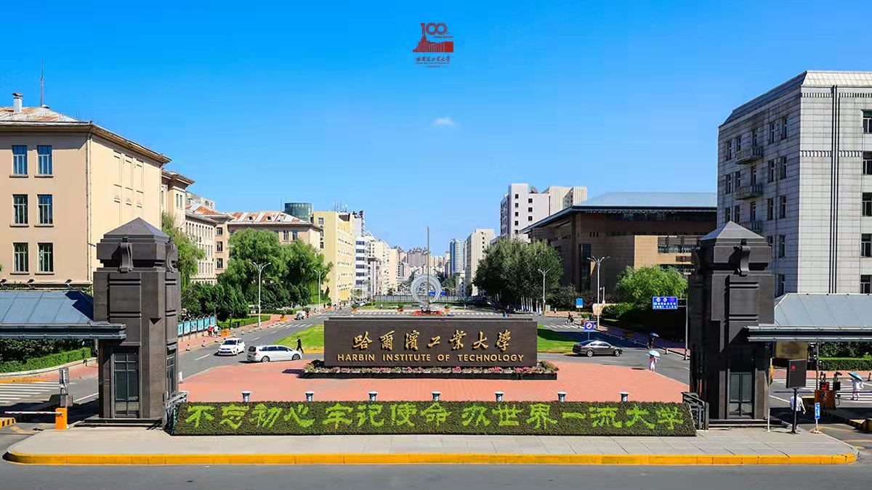
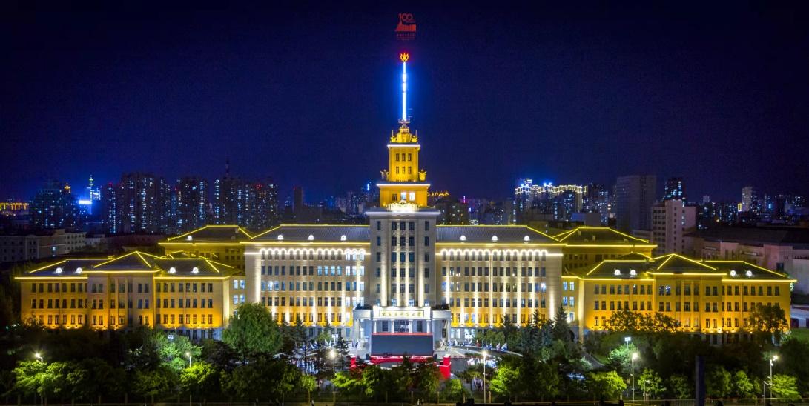
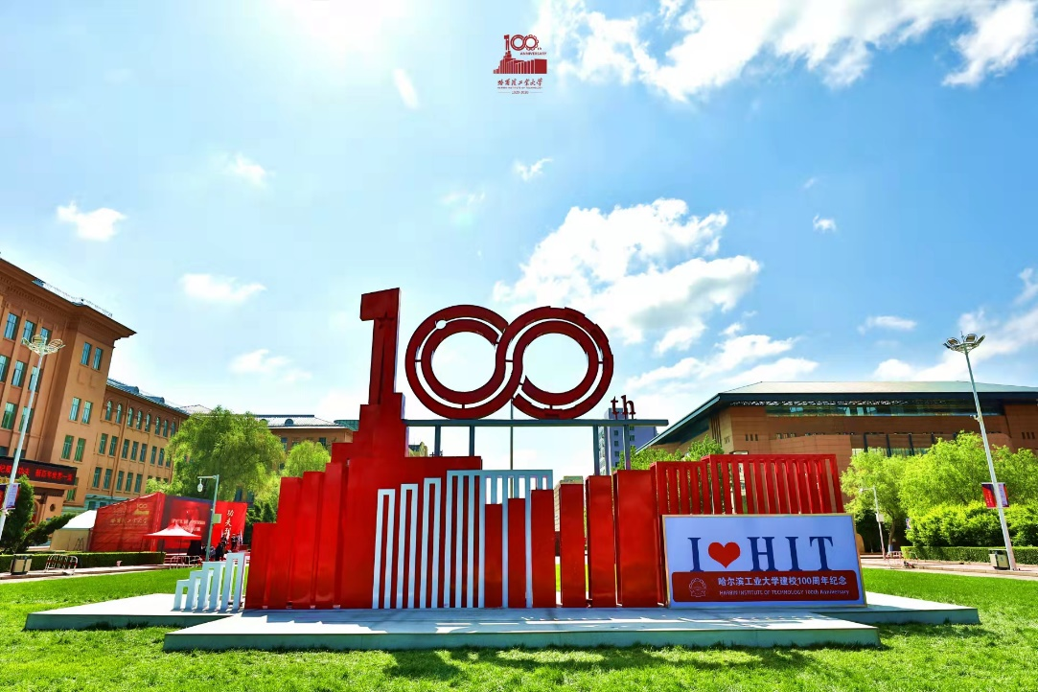
Available Disciplines & Research Fields
Schools | Disciplines | Research Fields
Astronautics | 0811  Control Science and Engineering | 1. Navigation, Guidance and Control  2. Control Theory and Control Engineering  3. Detection Technology and Automatic Equipment  4. Robots and Intelligent Systems  5. Systems Engineering and Simulation
 | 0801  Mechanics | 1. Fatigue and Fracture Mechanics  2. Structural Optimization Design  3. Micromechanics  4. Solid Dynamics  5. Thermo/Mechanical/ Electrical/Chemical Multi-field Coupling Mechanics  6. Material and Structural Mechanics in Extreme Environment  7. Advanced Composites and its Structural Lightweight Theory  8. Composite Materials and its Structural Mechanics  9. Reliability Analysis and Design of Composite Structures  10. Intelligent Materials and Structural Mechanics  11. Aerospace Structural Mechanics  12. Material/ Structure/ Function Integrated Design  13. Structural Dynamics and Vibration Control  14. Nonlinear Dynamics  15. Hydrodynamics  16. Dynamics Inverse Problem and Fault Diagnosis
 | 0825  Aeronautical and Astronautical Science and Technology | 1. Aircraft System Design  2. Flight Dynamics and Control  3. Aircraft Intelligent Autonomous Navigation, Guidance and Control  4. Deep Space Flight and Landing Return  5. Integrated Design and Simulation of Aircraft  6. Dynamics and Control of Complex Spacecraft  7. Space Environmental Effects of Spacecraft and its Countermeasures  8. Structure and Protection of Aerospace Vehicles
Mechatronics Engineering | 0825 Aeronautical and Astronautical Science and Technology | 1. Space Structure and Control  2. Aerospace High Precision Manufacturing Technology  3. Space Robot Technology  4. Space of Special Processing Technology  5. Aircraft Digital Manufacturing Technology  6. Aircraft Ground Simulation and Testing Technology
 | 0802  Mechanical Engineering | 1. Precision and Ultra-Precision Processing Technology  2. Micro-Nano Manufacturing Techniques  3. Special Processing and Special Material Processing Technology  4. Modern Design Theory and Method  5. Digital Design and Manufacturing Technology  6. Mechanical and Electrical System Control and Automation  7. Modern Sensor and Testing Technology  8. Fluid Flow Control and Automation  9. Robot Technology and System  10. Special Transmission Intelligent Design and Control  11. Tribology Basic Theory and Application Technology  12. Engineering Structure Design and Analysis  13. Vibration and Noise Control  14. Biomechanical Engineering  15. Production System Automation Technology  16. Manufacturing System Engineering Management  17. Vehicle Dynamics and Control  18. Vehicles Advanced Manufacturing Technology  19. Modern Design Theory and Method Of Vehicle  20. Vehicle Electronics and Control
Introduction to the School of Astronautics
The School of Astronautics, approved by the Ministry of Space Industry in June 1987, was founded by the merger of the Department of Control Engineering, the Department of Radio Engineering, the Department of Engineering Mechanics and Flight Vehicle System Designing Office. It is China’s first higher education institute which mainly focused on the education of specialists and research in the field of astronautics. The school is also the only affiliate of International Space University in Asia.
In the early 1990’s, both laser and optical engineering specialties were incorporated into the school. Through the support of the Ministry of Space Industry as well as the assistance from China Academy of Space Technology (CAST), the school established the earliest specialties on satellite and spacecraft environmental engineering in China. In 2009, the former Department of Radio Engineering independently formed its own school. The school presently oversees 12 departments and research centers offering 10 astronautic-related undergraduate majors spanning 6 primary disciplines and 15 subordinate disciplines. As the most competitive School of Astronautics in China, we offer outstanding opportunities to cultivate talent and conduct innovative and leading-edge scientific research. Through its strong leadership, specialty knowledge and experience, as well as focus on development, the School of Astronautics is internationally recognized as a driving force for innovation in the astronautics field and quickly becoming a world-class research institute.
Under the efforts made by generations of scholars, the school has gradually built up a profound academic foundation and developed a qualified group of distinguished scholars and well-known specialists. The paragon for the intellectuals today, Ma Zuguang has been praised as the top representative of the educators in HIT. At present, there are 140 professors among 400 staff members, including:
7 academicians of Chinese Academy of Engineering / Sciences
13 Cheung Kong Scholar professors
4 Visiting professors
9 winners of the National Outstanding Youth Foundation(including foreign nationality)
2 national famous teachers
2 innovation group of the Chinese National Natural Science Foundation
4 innovation groups of the Ministry of Education
3 innovation groups of national defense science and technology
In summary, the School of Astronautics ranks high both in education and research.
The school has established a close relationship with research institutes in both China Aerospace Science and Technology Corporation and China Aerospace Science and Industry Corporation. Through cooperation with these institutes, the school has established the first Astronautics major in China, set up Internship Base for students, and invited several specialists as visiting professors, including the chief designer of Chinese Lunar Orbitting Detection Project Sun Jiadong, and the chief designer of Chinese Manned Spaceflight Project Wang Yongzhi.
Additionally, our school’s close collaboration with PLA General Armament Department and the Second Artillery Force has greatly contributed to the construction of national defense.
The school actively undertakes international exchange through communicating and cooperating with related departments in more than 20 universities worldwide. The school has also invited 5 long- term overseas visiting specialists, and 17 overseas honorary specialists to share knowledge with students. In the past 3 years, the school has held about 10 international academic conferences, and has invited nearly 100 foreign specialists to give lectures. Additionally, nearly 100 HIT teachers have attended overseas international academic conferences, and more than 40 excellent young teachers have taken further studies at universities around the globe.
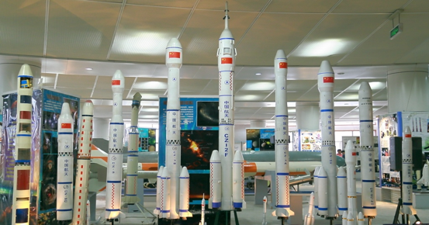
Introduction to the School of Mechatronics Engineering
Mechanical Engineering is one of the oldest disciplines, which was built up at the beginning of HIT in 1920, and is also one of the first established related disciplines in China. After decades of development, the School of Mechatronics Engineering currently comprises 15 departments and research centers. The discipline of Mechanical Engineering ranked No. 2 in 2002 and No. 4 in 2006 respectively at the academic assessment of the Ministry of Education, and was approved as the national key discipline in 2007.
The school is on a clear path to become a world-class school of Mechanical Engineering.
Mechanical Engineering is one of the oldest disciplines, which was built up at the beginning of HIT in 1920，and is also one of the first established related disciplines in China. After decades of persistent efforts and development, the School of Mechatronics Engineering has reached the following scale: it currently comprises 14 departments and research institutes (centers), the Engineering Graphics Section, the Departments of Mechanical Design. Mechatronic Engineering, Fluid Control and Automation, Manufacturing Engineering, Engineering Machinery and Logistics Technology, Industrial Design, Industrial Engineering, Aircraft Manufacturing, as well as the Engineering Training and Metal Technology teaching and research Center, the National Key Lab of Robotics and Systems, the Center for Advanced Production Technology, the Institute of Precision Engineering, and the Institute of Electro-hydraulic Serve Simulation & Test System.
The School of Mechatronics Engineering cultivates a teaching and research team with reasonable structure, active in academic thinking and excellent comprehensive quality. Until now, the school has a faculty of more than 460, including 2 academicians of the Chinese Academy of Engineering, 29 high-end talents, like Cheung Kong Scholars, Distinguished Young Scholars and New Century Excellent Talents, which is a team with vitality, high efficiency, and innovation. At present a total of 2,815 students are enrolled in the School, including 1,595 undergraduates, 783 masters' students and 437 doctoral students.
The School of Mechatronics Engineering has outstanding achievement in personnel training and scientific research. In personnel training, the school has cultivated a large number of high-level talents with professional dedication and innovation, which is highly recognized by the society. The employment rate of graduates is above 97% each year. In scientific research, the school has formed a scientific research system organically integrated with basic research, application pre-research, engineering application and industrial development. In the past 3 years, the school made a number of high-level scientific research achievements. It completed more than 580 research projects, with a total funding of exceeding 10 million.
At present, the School of Mechatronics Engineering has established academic links and postgraduate training relations with many other universities and research institutions in the United States, Britain, Japan, France, Germany, Russia, Canada, Australia, Italy, Switzerland, Sweden, Singapore, South Korea, Hone Kong, Taiwan, etc. As to the Department of Manufacturing Engineering for Aviation and Aerospace, it has been the authority to launch MS and PhD program of second-class discipline of Aeronautics and Astronautics Manufacturing Engineering (AAME) from Harbin Institute of Technology (HIT) in 1983 and 2001, respectively. Until now, AAME discipline possesses a key discipline laboratory for national defense for Aerospace Mechanism and Control Technology and a national innovation engineering base for Equipment Design & Manufacture Science and Technology. Furthermore, AAME was approved for key disciplines in Heilongjiang Province in 2007 and it hold advanced conditions of teaching and scientific research and International communication platform. Because of the implementation of scientific and technological plan and national key projects of Large Aircraft, Manned Space and Lunar Exploration Project in China, it leads to the demand of AAME professionals. HIT re-organized the Dep. Of AAME in 2008, which strengthen the construction of AAME discipline, and AMME discipline ranked fourth in subject evaluation of Ministry of Education (2012). Our community has a teaching scientific research strength of the teacher staffs whose knowledge and age structure is reasonable, it includes 18 professors (including 2 part-time professors, 1 overseas consultant professor, 2 distinguished professors, 1 national youth science and technology innovation leader), 8 associate professors and 7 lecturers. Dep. of AAME has excellent experimental conditions for teaching and scientific research. Professional teachers pay much attentions to curriculum system construction, teaching experimental condition construction and education reform. They emphasize on cultivating the practical ability and innovation consciousness of students. In recent 5 years, many teaching achievements have been achieved, including 2 second prizes in National Excellent Teaching Achievement (NETA), 1 first prize and 1 second prize in Provincial Excellent Teaching Achievement (PETA) . Dep. Of AAME pays attention to base and basic applied study. Based on requirement of national defense, aerospace serves, and some basic, frontier and exploratory researches were actively and deeply implemented. Currently, it has formed a research system featuring the aerospace mechanism and control, ultra-precision & special processing and infrared nondestructive testing. The research area is closely combined with national advanced manufacturing and space development program. Dep. of AAME has been responsible for a series of national important science and technology projects, including Lunar Exploration Project II and III, Shen Guang project and so on. Our research and teaching range from aerospace mechanism and control, to highly efficiency precision manufacturing technology, to aerospace robot, to aerospace special processing technology, to ground simulation and testing technology. During 2012 and 2014, Dep. of AAME undertakes more than 50 national scientific research projects and scientific research funds accumulate up to 180 million RMB. It has published more than 200 SCI/EI papers and has been authorized 18 national invention patents. It achieves many achievements, including 1 second prize in National Award for Technological Invention, 1 first prize in the Ministry of Education Technology Invention, 1 first prize in Heilongjiang Province Technological invention and 1 second prize in Heilongjiang Province Natural Science. With respect to international academic exchanges and cooperation, Dep. of AAME carries out a wide range of international academic exchanges and cooperation with Britain, USA, Japan, Germany, Canada, and Russia by organizing or participating in important international conferences, oral presentation and inviting foreign experts to give lectures, cooperative research and so on. So, you're invited to learn more about our research labs and our faculty.
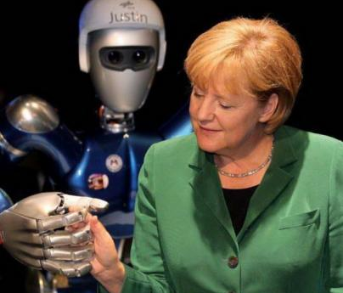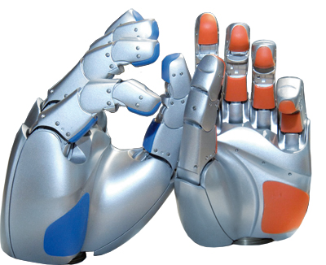
PhD Cultivation
To promote international exchange and cooperation, and improve the standard administration of education for international students, the following regulations have been made based on Regulations on the Administration of International Students in Chinese Higher Educational Institutions and Regulations on the Education of Doctoral Candidates in Harbin Institute of Technology.
I. Duration
The duration of doctoral education lasts 4 years.
II. Mode of education
Doctoral supervisors are responsible for the supervision of international doctoral candidates. According to requirement of training program and principle of teaching in line with students’ aptitude, supervisor should design training program. To promote international exchange and cooperation and to enable international students to better adapt to campus life, the team mode is encouraged which includes both Chinese and international doctoral candidates in the same research field so as to discuss important links in training program and major academic issues in their doctoral dissertations collectively. Supervisors should provide the equipment and conditions for the students to work in the laboratory or research group without violating confidentiality regulations.
III. Courses and credit requirements
International doctoral candidates are required to gain a minimum of 14 credits, Primary oral Chinese course（Degree Courses，4 credits）, 2 credits go to specialized core courses and a minimum of 4 credits go to optional courses, and based on their own language proficiency, the students can choose English Master Program courses in the related subjects as their optional courses.
Credits Requirements for PhD Program in English
Type of Courses |  | Credits
Degree Courses | Primary Oral Chinese Course | 4
 | Specialized Core Courses | 2
Optional Courses | Specialized Optional Courses | ≥4
Required Parts | Comprehensive Assessment | 1
 | Dissertation Proposal | 1
 | Interim Inspection | 1
 | Academic Activities | 1
Total Credits | ≥14
1. Degree courses (6 credits)
(1) Primary oral Chinese course (4 credits)
(2) Specialized Core Courses (2 credits)
2. Optional courses (no less than 4 credits)
4 credits go to specialized optional courses.
3. Required Parts including Comprehensive Assessment at the end of the first academic year accounts for 1 credit. Dissertation Proposal accounts for 1 credit. Interim Inspection accounts for 1 credit. Academic Activities account for 1 credit.
IV. Course selection
1. International students should fill out training program for doctoral candidates under the guidance of their supervisors, which, after being approved by the dean of the schools (departments), should be submitted to the secretary for being archived in the first two weeks of the semester. Students and supervisors should each keep a copy. The program is an important administrative document in the process of international students’ course studies and should be carefully followed.
2. Students need to select the courses in the HIT Graduate Education Integrated Management System on the internet in the first two weeks. The courses should be the same as the training program for doctoral candidates. The teaching director should check the results of the international student course selection.
3. Courses already selected in the program cannot be changed except under exceptional circumstances, in which case Application Form for Changing the Training Program must be filled out, which would then be solved by the discipline or school after being approved and signed by the supervisor and the dean. This must be completed 2 weeks within the beginning of each semester and each International student is only allowed to change a maximum of 2 courses each semester. The courses should be revised by international students in the HIT Graduate Education Integrated Management System in person in the first two weeks of the semester.
V. Language of instruction
International doctoral candidates can choose English as the language of instruction. Those who choose English as the language of instruction should ask their supervisors and department to help make relevant arrangements.
VI. Teaching method
Doctoral students in English Program will be coached by the teacher. Teachers can inform of the department or Graduate School about the problems difficult to handle, in order to ensure the quality of graduate courses.
VII. Assessment
Assessment of international students’ grades involves exam and check.
The degree course must be assessed by an examination and students’ scores will be assessed based on a hundred-mark system. Exams involve written and oral examinations or both.
Optional courses are assessed based on a hundred-mark system or pass-or-fail system. The assessment of optional courses takes one or more of the following forms: written, oral, book reports, research reports, etc.
VIII. Thesis/Dissertation Requirements
1. Language requirements
The following are regulations concerning the language used in international students’ thesis/dissertation based on The Regulations on the Language Used in Graduate Students’ Thesis/Dissertation (Document No. Academic Degrees [2007]08) as stipulated by the Academic Degrees Committee of HIT.
International doctoral candidates can choose to use English to compose and defend their dissertations. If composed in English, a Chinese summary of at least 3000 Chinese characters is required, which should be attached to the dissertation entitled “Detailed Summary”.
2. Requirements concerning doctoral dissertation of international candidates
2.1 Doctoral dissertation proposal
Doctoral dissertation proposal should be completed at the end of the first semester in the second academic year, and no later than the end of the second academic year. Doctoral dissertation proposal is generally conducted in the form of oral defense, and the written proposal should be submitted.
2.2 Interim dissertation inspection
Interim inspection of doctoral dissertation is implemented at HIT. In the middle of doctoral dissertation work, the related school will organize inspection panel (3-5 members) to examine the comprehensive capacity, the progress of the dissertation, and the work attitude, coupled with the energy put into the dissertation.
2.3 Publication of academic papers
The quantity and quality of academic papers published by international doctoral candidates is an important criterion for the conferring of doctoral degree. According to disciplinary reality, the Sub-Committee of Academic Degree should formulate their own higher disciplinary requirements for the publication of research papers, and implement them accordingly, making sure that the basic requirements of the university are met.
2.4 Composition of dissertation
Doctoral dissertation is a comprehensive summary of doctoral candidates’ scientific research work which describes their research results and reflects their research level. Doctoral dissertation is the basic criteria for the conferring of doctoral degrees. For specific requirements concerning the composition of doctoral dissertation, see Norms of Doctoral Dissertation Writing.
2.5 Pre-defense and defense of dissertation
Pre-defense ensures the quality of doctoral dissertation. International doctoral candidates can apply for pre-defense after completing the first drafts of their doctoral dissertations and after their first drafts being read and approved by their supervisors.
Oral defense of dissertation is a comprehensive assessment of international doctoral candidates’ research work and the quality of their doctoral dissertations. It is an important procedure for their application for doctoral degree.
IX. Requirements concerning Publication of Academic Papers of Doctoral Candidates
According to Regulations of the People's Republic of China on Academic Degrees and Interim Rules for Implementation of the Regulations of the People's Republic of China on Academic Degrees, doctoral dissertations should give evidence of their author’s capability to conduct scientific research independently and to produce creative results. The quantity and quality of academic papers being published by doctoral candidates is an important criterion for the quality of education and conferring of doctoral degrees. The following are requirements concerning the publication of academic papers by doctoral candidates in HIT.
1. The Sub-Academic Degrees Committee of Control Science and Engineering
Doctoral candidates within the discipline of control science and engineering should have more than 3 academic papers published, among them 1 is written in English. At the same time, 1 academic paper is published in SCI journal, or 2 papers are published in EI journals.
These requirements apply to doctoral candidates enrolled in the autumn semester of 2014 and onwards.
2. Sub-Academic Degrees Committee of Aeronautic and Astronautic Science and Technology
Doctoral candidates within the discipline of the above-listed disciplines should meet one of the following requirements: (1) have 1 academic paper published in key international academic journals (for specific information, see Appendix 4); (2) have 2 academic papers published in SCI or EI international journals or international conference proceedings, with at least one of which published in international academic journals; (3) or have no less than 3 academic papers published in core academic journals (including ISTP international conference proceedings), with at least 1 of which published in EI journals except Journal of Harbin Institute of Technology (English or Chinese edition) and Journal of Materials Science and Technique, and at least 1 written in a foreign language.
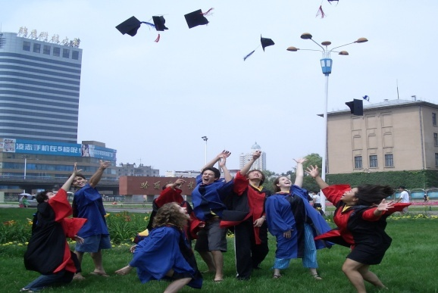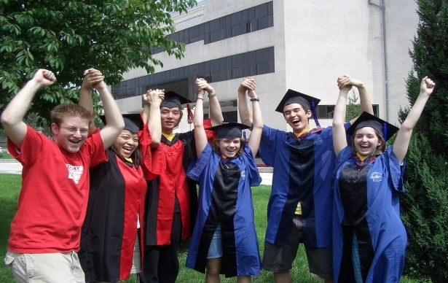
Scholarship and Financial Support
The applicants are welcome to apply for Chinese Government Scholarship (CSC) at Harbin Institute of Technology. The full scholarship will cover the following items:
1. Exempt from registration fee, tuition fee, and accommodation fee;
2. 800 RMB per year for Comprehensive Medical Insurance;
3. Monthly stipend is granted to the students at the following rates after freshman coming to China to register, the stipend will not be reissued before coming China: Doctoral degree candidate: 3,500 RMB/month
Eligibility
- Applicants must be non-Chinese nationality in good health.
- International students out of China or former graduates of Chinese universities.
- Educational background required and age limit:
Applicants for doctoral degree studies must have master’s degree and be under the age of 40.
- Excellent performance in study.
- Applicants should have good ability in scientific research.
Note: The scholarship cannot be combined with any other scholarships.
Application Deadline
Applicants should post all the required documents to the Contact Person at APSCO by March 15, 2022 (the application date is defined as the date on which APSCO receives the paper application materials).
Application Procedures and Required Documents
The applicants need to provide the following materials truly and correctly (two sets).
- Application Form for Chinese Government Scholarship.
The CSC Online Application System is available at: http://studyinchina.csc.edu.cn/ .
Scholarship type: B
University code: 10213
- Highest full-time study diploma (original notarized document in English or
Chinese).
Note: If applicants are university students, they should provide original notarized pre-graduation certificate in English or Chinese. Notarization must be carried out through formal institution, the signature or seal from school or working unit does not have the effect of notarization.
- Transcripts (It is not required to be notarized, but must be signed and sealed
from the university. The transcripts in other languages must be translated in English or Chinese with notarization).
- A study or research plan (not less than 800 words in English or Chinese).
- Two recommendation letters by professors or associate professors in English or
Chinese.
- Passport copy (valid for one year at least).
- Photocopy of Foreigner Physical Examination Form.
Note: The form is printed by the Chinese Health and Quarantine Department and is restricted to those who study in China for more than 6 months. The medical examinations must cover all the items listed in the Foreigner Physical Examination Form. Incomplete records or those without the signature of the attending physician, official stamp of the hospital or a sealed photograph of the applicants are invalid. The medical examination result is generally valid for 6 months.
- Language proficiency certificate
Chinese-taught programs: report of HSK4 or above (valid for two years), English proficiency certificate
English-taught programs: IELTS (5.5 or above) or TOEFL (80 or above) report (valid for two years) or English proficiency certificate provided by previous academic institutions.
- Certificate of No Criminal Record.
- Acceptance letter (not a must).
Applicants are encouraged to contact the professors prior to application and enclose the acceptance letter from supervisors of HIT.
More Information
Schools & Faculties information, please visit http://www.hit.edu.cn/11296/list.htm
Supervisor information, please visit http://homepage.hit.edu.cn/home-index
Relative format download, please visit http://studyathit.hit.edu.cn/post/index/459
Contact Information
APSCO:
Ms. Charis Xiong
Add: ASIA-PACIFIC SPACE COOPERATION ORGANIZATION (APSCO)
Building 13&14, Section 3, No.188, South Street Fourth Ring, Fengtai District,
Beijing, China
E-mail: charis@apsco.int
Telephone: +86-(0)10-6370 2677 Ex.404
Website: http://www.apsco.int
HIT:
Ms. Aileen ZHAO
Add: Room 302, No.11 Siling Street, College of International Education,
Harbin Institute of Technology, Nangang District, Harbin, 150001, China
E-mail: StudyatHIT@hit.edu.cn
Telephone: +86-451-86402455
Website of HIT: http://www.hit.edu.cn/
Website of College of International Education, HIT: http://studyathit.hit.edu.cn/

