
HARBIN INSTITUTE OF TECHNOLOGY

HIT-APSCO

Full English PhD Program 2026

Introduction to Harbin Institute of Technology

Harbin Institute of Technology (HIT) was established in 1920 in Harbin, Heilongjiang, China. In 1954, HIT became one of China’s first six leading universities. Presently HIT is a member of China’s top nine University Union (C9). It is a National Key University with science and engineering as its core and has developed to include management, liberal arts, economy, law and other disciplines. In the US News ranking for the Best Global Universities for Engineering, HIT ranked No.2 in China and No.5globally.
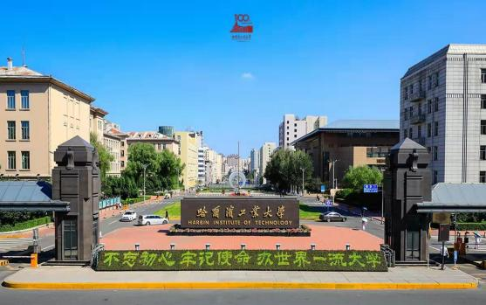

Available Doctoral Programs

Schools | Major
Astronautics | Mechanics
Astronautics | Control Science and Engineering
Astronautics | Aeronautical and Astronautical Science and Technology
Mechatronics Engineering | Mechanical Engineering
Mechatronics Engineering | Aeronautical and Astronautical Science and Technology
Materials Science and Engineering | Materials Science and Engineering
Energy Science and Engineering | Power Engineering and Engineering Thermophysics
Computer Science and Technology, Faculty of Computing | Software Engineering
Physics | Physics
Faculty of Life Science and Medicine | Biomedical Engineering
Electronics and Information Engineering | Information and Communication Engineering

Introduction to Schools

1. School of Astronautics
Established in 1987, the School of Astronautics of Harbin Institute of Technology (HITSA) is the first in China dedicated to cultivating talent and conducting cutting-edge research in the field of aerospace. HITSA takes it as its mission to tackle scientific and technical challenges in astronautics and to promote the research serving major national needs as well as providing a global impact on society-at-large. HITSA has formed a research and teaching system combining fundamental studies and engineering applications characterized by wideness in scope and strong synergism in

five disciplines: Mechanics, Control Science and Engineering, Aeronautical and Astronautical Science and Technology, Optical Engineering, Electronic Science and Technology. The major research areas currently include: design of spacecraft and craft system, deep space exploration, autonomous navigation and control, novel guidance and simulation, advanced composite materials and structures, dynamics and control of aerial vehicles, laser communication, remote sensing and diagnosis, space optics and information technology, and IC design and MEMS, etc.
The teaching faculty of HITSA has 356 members, among whom are 155 professors, 158 associate professors, 4 members of Chinese Academy of Sciences, 6 members of Chinese Academy of Engineering, 1foreign member of the Academia Europaea. Prof. Shanyi Du and Prof. Jinsong Leng are elected as World Fellows of International Committee on Composite Materials whose vice president is Prof. Leng. Prof. Guangren Duan and other three researchers were elected as IEEE Fellows. Prof. Huijun Gao was voted the world’s most influential scientific minds in 2014 by Thomson Reuters.
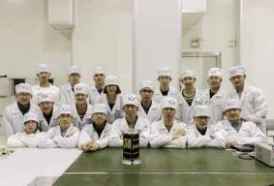
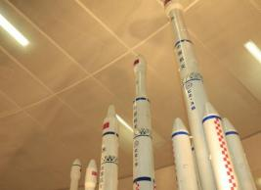

There are currently 1600 undergraduate students and 2000 graduate students enrolled in the school. HITSA has initiated a new talent cultivation mode involving joint training and practical educating. The school has also established the Lilac micro- Nano satellite innovation factory for students. The "Lilac-2" satellite, launched by the team of Lilac micro-Nano satellite, is the first micro-Nano satellite independently designed, developed and controlled by students, and the "Lilac-1" satellite is a part of the QB 50 Project of European Space Agency.

HITSA has become one of the most important Chinese institutions committed to the education of talented scholars and specialists in astronautics and the advancement of aerospace industry in China. The school enjoys a high reputation abroad for its distinguishable contribution in the field including but not limited to micro-satellite, laser communication, composite materials and control theory. Up to now, the school has designed and launched 20 micro satellites and first accomplishes the task of circumlunar flight of micro satellites. Operationally responsive microsatellite system technology and satellite laser communication technique are at the cutting-edge of technological development.
In the future, aiming at key enabling technology, cutting-edge technology and concept innovation in astronautics, HITSA will make greater contributions to aerospace technology and industry, by pushing interdisciplinary integration, promoting international collaboration and training top-level innovative talents.
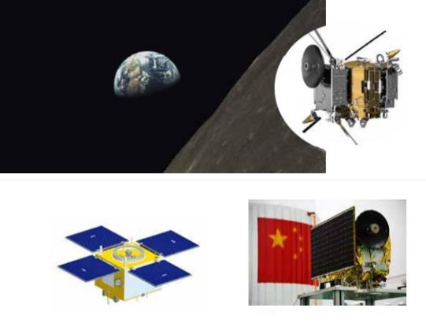

2. School of Mechatronics Engineering
The School of Mechatronics Engineering (SME) was founded in 1993 ， whose predecessor was the department of electrical and mechanical engineering ,which was founded in 1920. At present, SME not only focuses on mechanical engineering, with the coordinated development of aerospace science and technology, design and other disciplines, but also cultivates innovative and leading talents for future development. The discipline of Mechanical Engineering was rated as A+ in the fourth disciplinary evaluation, and it is a key discipline for double first-class construction.
SME has 294 faculties, including 116 professors/ researchers, 125 associate professors/associate researchers, 53 lecturers and more than 40 top talents with the title of the Chinese Academy of Engineering, Yangtse River Scholar, Youth talent program of NSFC, etc. By now SME owns 20 national or provincial and ministerial bases, including the State Key Laboratory of Robotics and System, Mechanical engineering experimental and teaching demonstration center, etc. SME also owns 1 foundation for innovative research group of NSFC and 6 national teaching and research innovation groups.
SME has achieved a number of research results with international standards, including first arc welding and spot welding robot in our country, the first CNC ultra-precision machining machine in our country and the first space orbit maintenance robot in our country, etc. SME has won 13 national science and technology awards and 130 provincial and ministerial science and technology awards. In recent years, SME focuses on major national projects such as "manned space flight", "deep space exploration" and "nuclear fusion", has carried out distinctive research work on robotics and mechatronics, advanced mechanical design, ultra precision manufacturing, non-standard equipment manufacturing, micro-nano manufacturing, etc. In the past 3 years, the annual research income is over 400 million RMB.

SME now owns totally 3200 students, including about 800 Ph.D students, about 800 master students, and about 1600 undergraduate students. It has trained more than 10,000 key talents of various types for the country, which covers many fields such as aviation, aerospace, shipping, nuclear technology and equipment manufacturing.
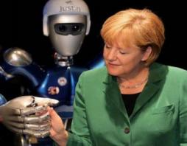
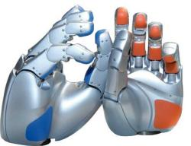

3. School of Materials Science and Engineering
The School of Materials Science and Engineering was established November 28,1993 from the original Department of Metal Materials and Technology and the Analysis and Measurement Center. It consists of five departments and three state key laboratories. In addition, the school has a Teaching Experiment Center. The School houses a 20,889 square meter laboratory building and over 400 million RMB worth of facilities.
The school currently has nearly 200 academic staff, including 4 academicians of CAE, 98 professors and 78 associate professors. More than 90% of the staff hold doctoral degree. From 1993, 1,611 Ph.D students, 6,321 master students and 7,923 undergraduates have obtained their degrees. Currently, there are 2,393 students, including 1172 undergraduates, 612 master students and 609 Ph.D students.

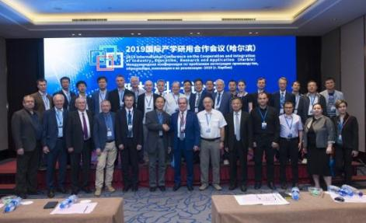
Since 1993, the school has carried out thousands of national research projects.
18 national awards have been obtained, including 2 National Natural Science Awards, 9 National Technology Invention Awards, and 7 National Science and Technology Progress Awards. Its major research interest lies in high performance structural materials, functional materials, composite materials, space materials and evaluation, special plastic forming, special solidification forming, material interconnection, surface engineering, and digitization of material processing, etc.
The construction goal of MSE is to build a world-class high-level material science and engineering discipline.

4. School of Energy Science and Engineering
School of Energy Science and Engineering ，was established in 1954, and consisted of 2 departments which are Energy and Environment Engineering Department and Flight Vehicle Propulsion and Fluid Dynamics Department ， 10 institutes or centers. Three undergraduate disciplines are available: Thermal Energy and Power Engineering, Flight Vehicle Power Engineering and Nuclear Reactor Engineering.

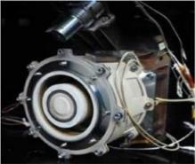
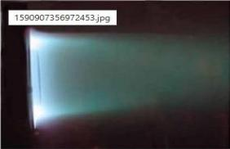

School of Energy has a strong reputation in teaching and scientific research. There are one national engineering laboratory, one national lecturing exemplary on mechanics, one national exemplary laboratory. In recent years, School of Energy has been awarded 2 second-class National Award for Natural Sciences, 2 second-class National Award for Technological Invention and 4 second-class Reward of National Science and Technology Progress. School of Energy has 100 teachers including 40 professors, among them there are 2 academicians of the Chinese Academy of Engineering. There are 2 winners of the National Science Fund for Distinguished Young Scholars, 2 Changjiang Distinguished Professor, 1 National Renowned Teachers, 9 winners of China Young Scientists Award. Among the teachers, there are 61% who have experienced at least one year scholar visiting abroad. School of Energy has 1190 students including 20 international students.
School of Energy has constructed a wide and solid international collaboration with more than 30 universities in more than 20 different countries, and signed joint training agreement with 6 universities including Moscow Aviation Institute. Up to now, School of Energy has fully participated with the Shanghai Cooperation Organization, established the Sino-EU doctoral school for Sustainability Engineering, and completed Erasmus + lpeb project. For increasing the international influence in energy field, School of Energy held “New Energy” international summer school annually from 2015 and also series of international symposiums including the 7th International Symposium on Coal Combustion. Meanwhile, School of Energy plays an important role in several international research institutions such as China-USA Joint Research Center on Clean

Energy.
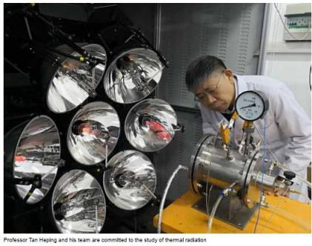

5. School of Computer Science and Technology
The Computer Specialty in Harbin Institute of Technology was founded in 1956, which is one of the earliest computer disciplines in China. In 1985, it developed into the Department of Computer Science and Engineering. In 2000, the School of Computer Science and Technology was founded. Currently, the School of Computer Science and Technology has one national first class key discipline of Computer Science and Technology, one post-doctoral station, one National Teaching Team, National Science and Technology Innovation Team and one .Innovation Research Team of COSTIND. It has 7 doctoral degree programs and 7 master’ degree programs, among which the Doctoral Degree Program on Computer Application Technology established in 1986 is the first batch of national key discipline, the Doctoral Degree Program on Computer Architecture founded in 1981 as the first batch of Chinese doctoral degree program is also the national key discipline. It ranked A in the third-round of China discipline Ranking by the Ministry of Education.

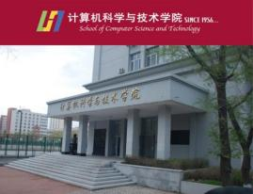
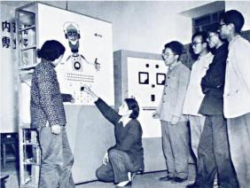

The School of Computer Science and Technology at HIT has been ratified as a key discipline in the National “211 Project”, “985 Project” and “the double first-class computer discipline construction group” . Hundreds of research projects funded by the state or ministries have been accomplished in the school; fruitful achievements have been gained and awarded by the state, ministries and provinces. More than 100 patents and software copyrights have been achieved by the school. After years of efforts and development, the school has formed more than twenty research fields in the discipline of computer application technology and computer architecture, such as intelligent human-computer interface, natural language understanding and Chinese information processing, mass data processing, computer network and information security, high reliable and fault-tolerant computation, intelligent computing for enterprises and service computing, bio-metrics and bio-computing, intelligent robots, sensor network ,mobile computing ,wearable computing and so on.

6. School of Physics
The School of physics pays attention to basic research and interdisciplinary, and improves the original innovation ability. Under the guidance of academicians of the Chinese Academy of Engineering (CAE), Dr. Yueguang Lv and Dr. Min Gu, our school has made great progress over recent years with high-quality research achievements. Our discipline listed among top 1% of global ESI list, ranked 12th by the Ministry of Education in 2012, and ranked B+ in the 2016 national discipline assessment. The

School of Physics has four key research areas including optics, condensed matter physics, particle and nuclear physics, and plasma physics. Optics is one of the state key disciplines equipped with the Ministry of Industry and Information Technology (MIIT) key laboratories. While simultaneously promoting basic and interdisciplinary scientific research, the school of physics carries out researches in micro-nano optical regulation and application, plasma, and particle physics. In the past five years, more than 600 SCI papers have been published in high-impact peer-reviewed journals, Physical Review Letters, the Science family of journals, the Nature family of journals. We undertook one major project of the 973 Program, and led the planning and construction of three areas of the Space Environment Ground Simulation Infrastructure of the National Big Science Project, including atomic molecular physics, space particle radiation, and plasma environment research. The School of Physics values opening up and international communication. The Sino-Russia Joint Research Center for Plasma Physics and Application is established.

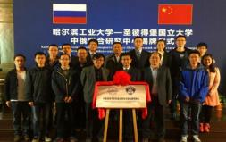
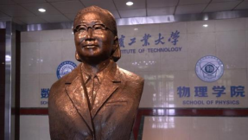

The School of Physics attaches great importance to building a strong faculty team, training talents for national strategy. We have an MIIS Research Teaching Innovation Team and Heilongjiang Provincial Physics Teaching and Research Team. We have a National Experimental Teaching Demonstration Center for applied physics. Our undergraduate team participated in the China Undergraduate Physics Tournament (CUPT) and won the National Special Award for 6 consecutive years from 2014 to 2019, 4 of which were national champions. Many alumni became academicians, generals and Changjiang Scholars.

The School of Physics will continue to develop upon its existing key areas with a focus on interdisciplinary research and innovation and the construction of basic infrastructure. By actively training and bringing in talented junior faculty, we are advancing the scientific and technological research and fostering innovative students in an open and inclusive environment.

7. Faculty of Life Science and Medicine
Faculty of Life Science and Medicine, founded in 2011 and growing out of the Department of Life Science and Engineering launched in 1995, is a newly established college at Harbin Institute of Technology (HIT) aiming at training leading talents in frontier and interdisciplinary science. SLST has a National and Local Joint Engineering Research Center, a Key Laboratory of the Ministry of Industry and Information Technology, a Provincial Key Laboratory, and a Provincial Engineering Research Center. Biology and Biochemistry entered the top 1% of ESI in 2015, and Clinical Medicine entered the top 1% of ESI in 2017. According to 2019 and 2020 US News Rankings of Best Global Universities, HIT’s Biology and Biochemistry was ranked in the top ten in China.
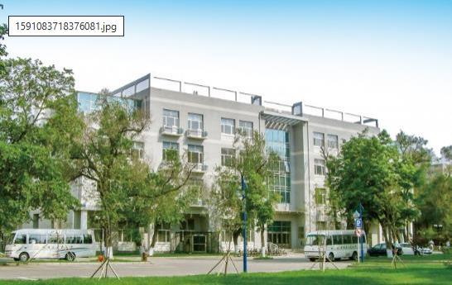
SLST offers two undergraduate majors (Biotechnology and Bioengineering)

and the first-class doctor degrees in two disciplines (Biomedical Engineering and Biology). Biotechnology is selected as the Provincial Key Specialty and the Provincial First-class Undergraduate Professional Construction Sites. Biomedical Engineering is a new interdisciplinary key discipline of the Ministry of Industry and Information Technology, provincial key discipline and national defense specialty.
SLST has 22 professors/researchers, 19 associate professors/associate researchers of faculty, including one professor with the Yangtze River Scholar Award provided by the Ministry of Education, two winners of The National Science Fund for Distinguished Young Scholars, two winners of National Science Fund for Outstanding Young Scholars and one professor supported by “the Cheung Kong Scholars Program”.
SLST has undertaken 48 national projects, such as the National Key Research and Development Program, and National Natural Science Foundation in recent years, and published four scientific explorations in Nature as the first unit since 2014. The discovery of the crystal structure of a ligase complex in the HIV virulence factor (VIF), in 2014, have solved the mystery in this field for more than 30 years, which is of great scientific significance and provides the structural basis for developing novel anti-HIV drugs. Another research result, in 2019, reveals the structure of a complex responsible for antigen recognition in T cells, for the first time, which is a major original discovery made by Chinese scientists on the basis of immunology.

8. School of Electronics and Information Engineering
Originating from the Department of Radio Engineering founded in 1959, the School of Electronics and Information Engineering (SEIE) has 6 undergraduate majors including communications engineering, electronics and Information engineering, information countermeasure technology, remote sensing science and technology, electromagnetic field and wireless technologies, measurement and control engineering and intelligence. Combining the international academic frontier with the country's major strategic needs, the school has formed a number of characteristic scientific research directions. The discipline of Information and Communication Engineering was

evaluated as A- in the 4th round of disciplines evaluation by the Ministry of Education in 2016. SEIE has always adhered to the fundamental task of cultivating talents by virtue and the central position of talent training, and has established a "Research- Oriented, Personalized and Elitism" innovative talent training system and project driven innovative talent training mode, and has achieved outstanding effect. By 2020 SEIE has trained more than 8300 undergraduates, 3200 masters and 520 PhD students. They have grown into leading engineering talents in relevant fields, play essential roles in different areas.
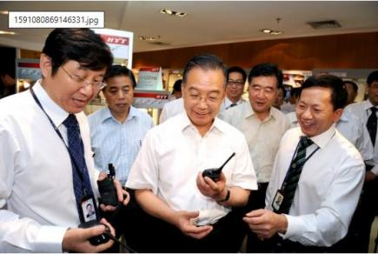
The school has 154 faculty members, including one academician, two winners of in the National Science Fund for Excellent Young Scholars, two members of the Recruitment Program in the Key Talent Program, four members of the Recruitment Program for New Century Excellent Talents in University, 33 professors, 54 associate professors, and 62 doctoral supervisors. Professor Yongtan Liu, the subject leader, the academician of the Chinese Academy of Sciences and the Chinese Academy of Engineering, is a famous expert in the field of radar and electronics information systems in China and won the State Preeminent Science and Technology Award in 2018. SEIE has 6 key laboratories and engineering research center of the Ministerial and Provincial level and participated there 2011 Collaborative Innovation Centers of the Ministry of Education. Annual research funds are more than 100 million RMB. SEIE won more than 10 National, Provincial and Ministerial science and technology awards in the

past 5 years. More than 30 teachers have served in international academic organizations or served as editorial boards of international journals, and the international academic influence of the school has been increasing.

Scholarship and Financial Support
I. Application Deadline

Applicants should email all the required documents to the Contact Person at APSCO by December 22, 2025 (the application date is defined as the date on which APSCO receives the email application materials).

II. Application Portal
The CSC Online Application System is available at http://studyinchina.csc.edu.cn/ Scholarship Type: B
HIT's University Code: 10213

The HIT Online Application System is available at https://hit.at0086.cn/student

III. Scholarship Coverage

1. Tuition fee & on-campus dormitory fee;
2. Comprehensive medical insurance: CNY800/year;
3. Monthly living allowance: No stipend is issued before arrival at the university. Doctoral students: CNY 3,500/month;

IV. Scholarship Duration
The duration of doctoral degree programs typically takes 4 years.

V. Eligibility

1. Applicants must be in good health both mentally and physically;
2. Applicants must be citizens of a country other than the People's Republic of China;

3. Consciously abide by the laws and regulations of the People's Republic of China and the rules and regulations of the university;
4. No Double Benefits Allowed - Students cannot receive multiple scholarships;
5. When applying for a doctoral degree program, be a master's degree holder under 40;
6. Language proficiency certificate: TOEFL≥80 scores, academic IELTS≥6.0 (no subtest lower than 5.5). If the language of instruction in the previous degree was English, the applicant can provide the English language instruction certificate issued by the previous degree institution; No requirement for applicants' Chinese proficiency;
7. Proof of outstanding academic achievements, sports, art, cultural exchanges, public welfare activities, etc. (optional).
Note: Scholarship students are not eligible for other scholarships established by the Chinese Government and admission institutions during the same period.

VI. Application Documents

The application documents in other languages must be notarized in either English or Chinese.
1. Application Form for Chinese Government Scholarship is available at http://studyinchina.csc.edu.cn/;
2. Passport homepage
3. Highest graduate certificate (the expected graduation certificate can be acceptable, but the original graduation certificate must be submitted at the time of registration);
4. Academic transcripts (from undergraduate program onwards);
5. Language proficiency certificate;
6. A study plan at least 1,500 words (writing according to HIT requirements);
7. Two recommendation letters from professors or associate professors. (The content shall describe the applicant's study objectives, comprehensive abilities, and

evaluation of future development);
8. Physical Examination Record for Foreigners (valid within six months). The physical examination must cover all the items listed in the examination form. Incomplete records or those without the attending physician's signature, the hospital's official stamp, or a sealed photograph of the applicant are invalid;
9. Bank receipt of application fee：USD 60 or CNY 400;
10. Non-criminal record report (usually issued within six months before the application submission date).

VII. Application Process

Step 1: Login Chinese Government Scholarship Application System, it is available at http://studyinchina.csc.edu.cn/ and complete the application, download the CSC Application Form after completion.
Program Category Type: B
HIT's University Code: 10213
Step2: Pay the application fee of CNY 400 or USD 60.
Remittance Information:
Beneficiary Name: Harbin Institute of Technology
Account Number: 3500040109008900513
Bank Name: Industrial and Commercial Bank of China, Harbin, Da Zhi Branch
Bank Address: 318 East Dazhi Street, Harbin, People's Republic of China
SWIFT/BIC: ICBKCNBJHLJ
Note: 1. The application fee is non-refundable. Currently, Alipay or WeChat payment is not supported.
2. Please mark the applicant's passport name and passport number on the remittance voucher.
Step3: Login Harbin Institute of Technology Application System, it is available at https://hit.at0086.cn/student , upload the CSC Application Form and other required materials to complete the application.

VIII. Important Notes
1. HIT can adjust the selected majors and study duration according to the applicant's educational background and study plan. If the applicant's conditions or application documents do not meet the provisions or requirements, the application shall be considered invalid and not accepted.
2. Applicants cannot change the professors, specialties, universities, study duration, or teaching language specified in the Admission Notice after registration.

IX. More Information
For more information regarding CSC scholarship, please visit
Chinese Government Scholarship
To find a supervisor, please visit http://homepage.hit.edu.cn/home-index
Schools & Faculties information, please visit: http://en.hit.edu.cn/

X. Contact Information
APSCO:
Ms. Charis Xiong
Add: ASIA-PACIFIC SPACE COOPERATION ORGANIZATION (APSCO)
Building 13&14, Section 3, No.188, South Street Fourth Ring, Fengtai District, Beijing, China
E-mail: charis@apsco.int
Telephone: +86-(0)10-6370 2677 Ex.404
Website: http://www.apsco.int
HIT:
Ms. PIAO Yuejin
Add: Room 214, College of International Education,
Harbin Institute of Technology, Nangang District, Harbin, 150001, China

E-mail: StudyatHIT@hit.edu.cn
Telephone: +86-451-86418461
Website of HIT: https://www.hit.edu.cn/
Website of College of International Education, HIT: http://studyathit.hit.edu.cn/

